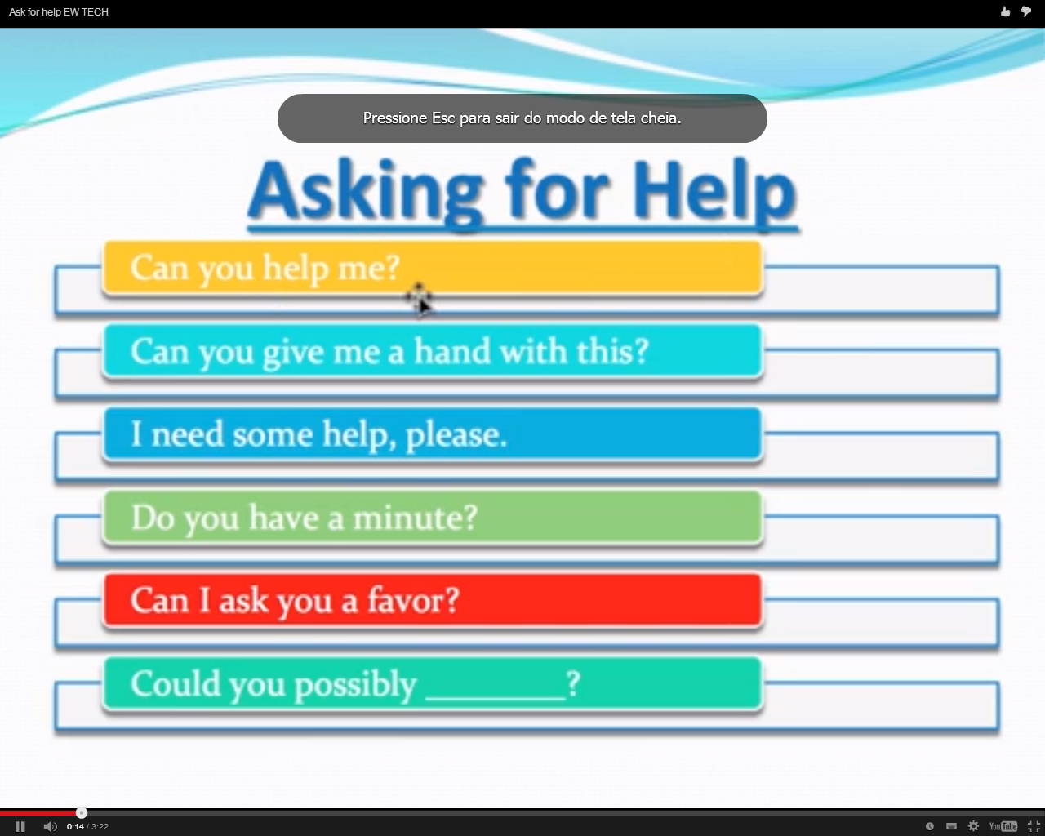

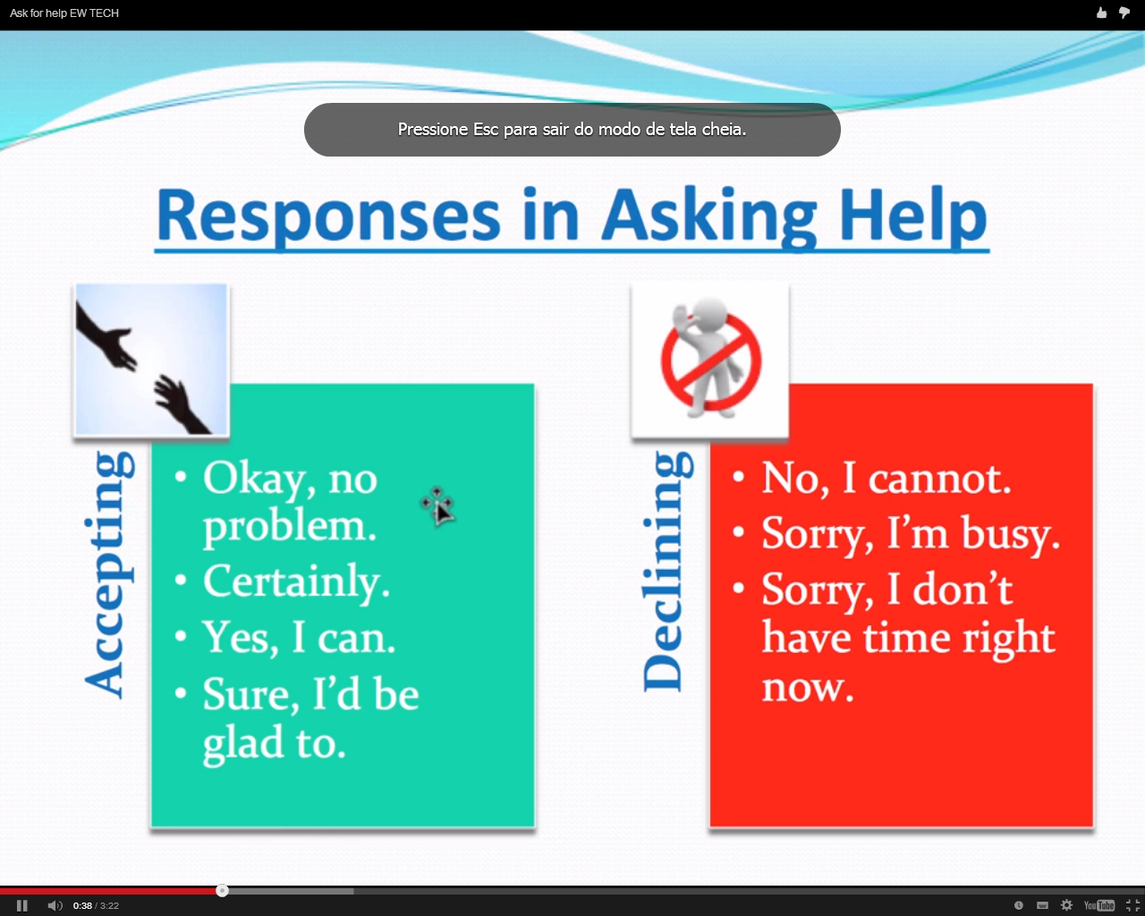

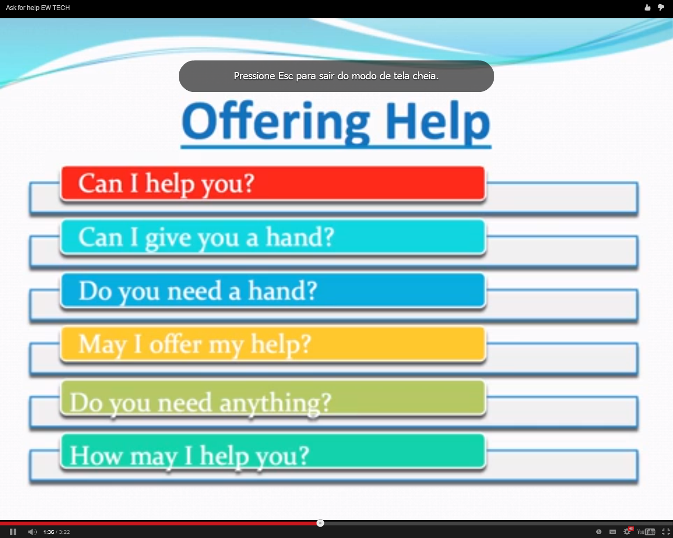

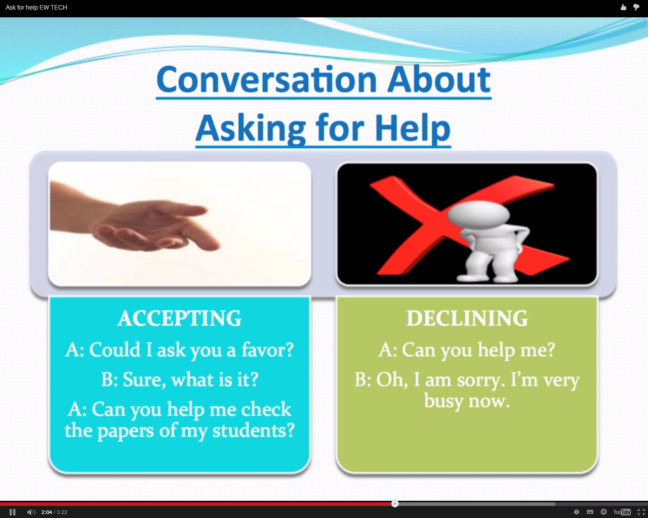

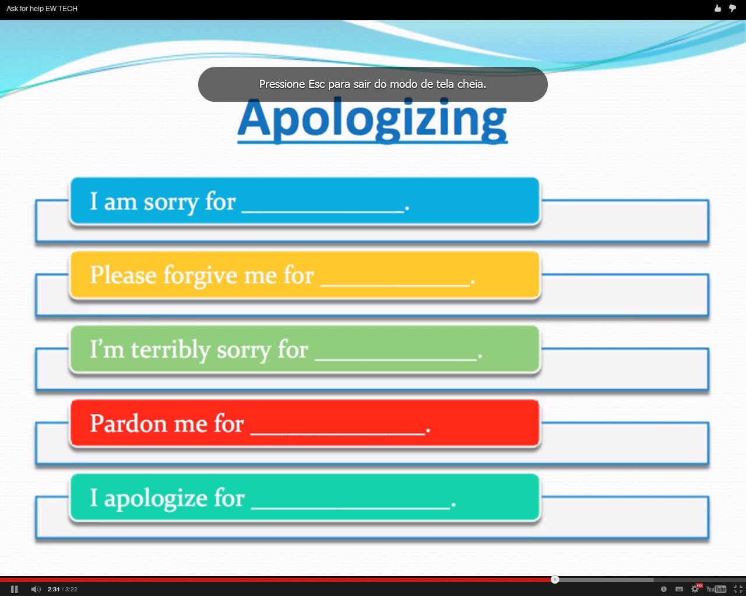

|  |  |
| --- | --- |
| **1** | **A continuous action in the past which is interrupted by another action or a time:**  I **was taking** a bath when the telephone rang. At three o'clock, I **was working**. |
| **2** | **Background information, to give atmosphere to a story:**  It was a beautiful day. The birds **were singing**, the sun **was shining**and in the cafes people **were laughing** and **chatting**. |
| **3** | **An annoying and repeated action in the past, usually with 'always':**  He **was always leaving** the tap running. (In the same way as the **[Present Continuous](http://www.perfect-english-grammar.com/present-continuous-use.html)**) |
| **4** | **For two actions which happened at the same time in the past:**  I **was watching** TV and he **was reading**. |

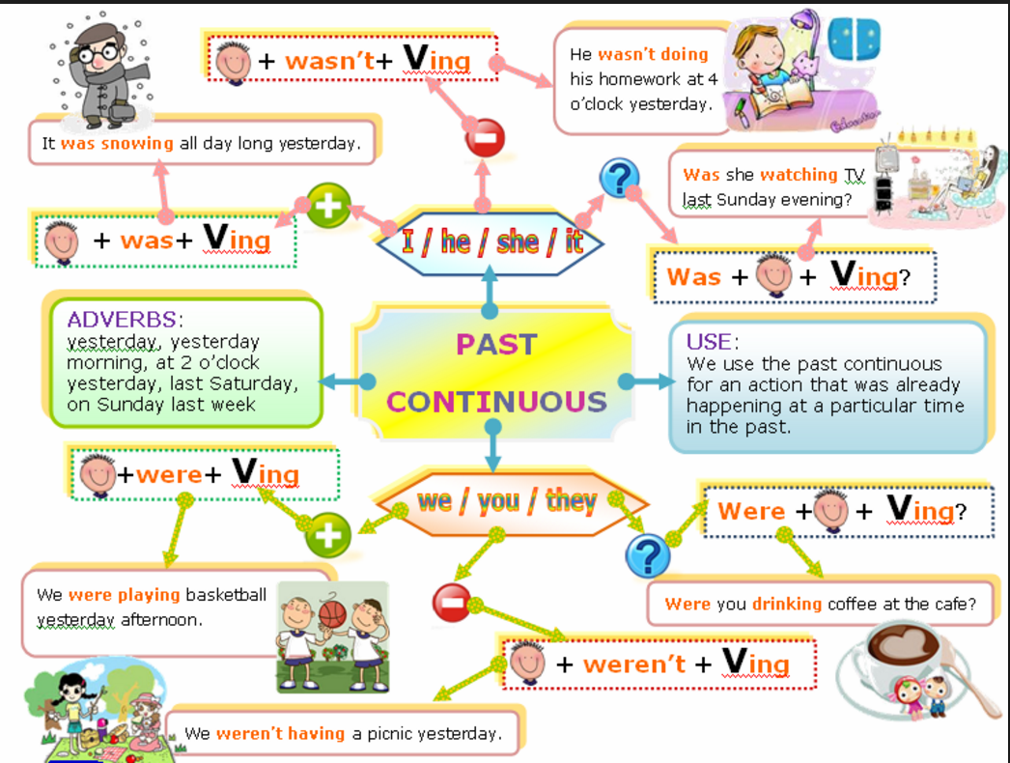

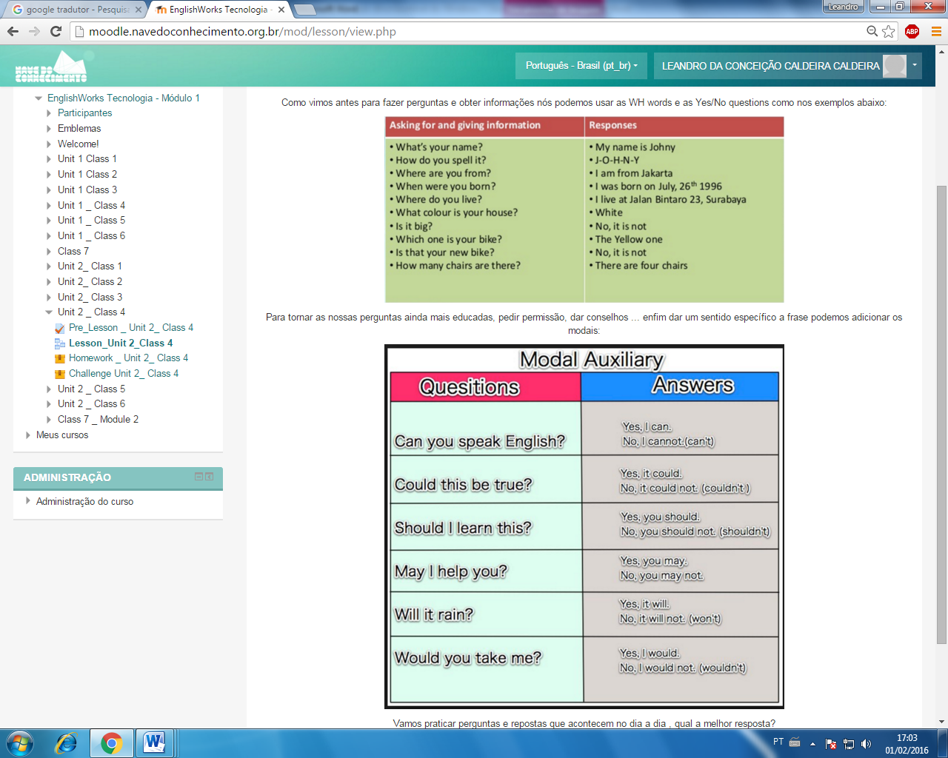

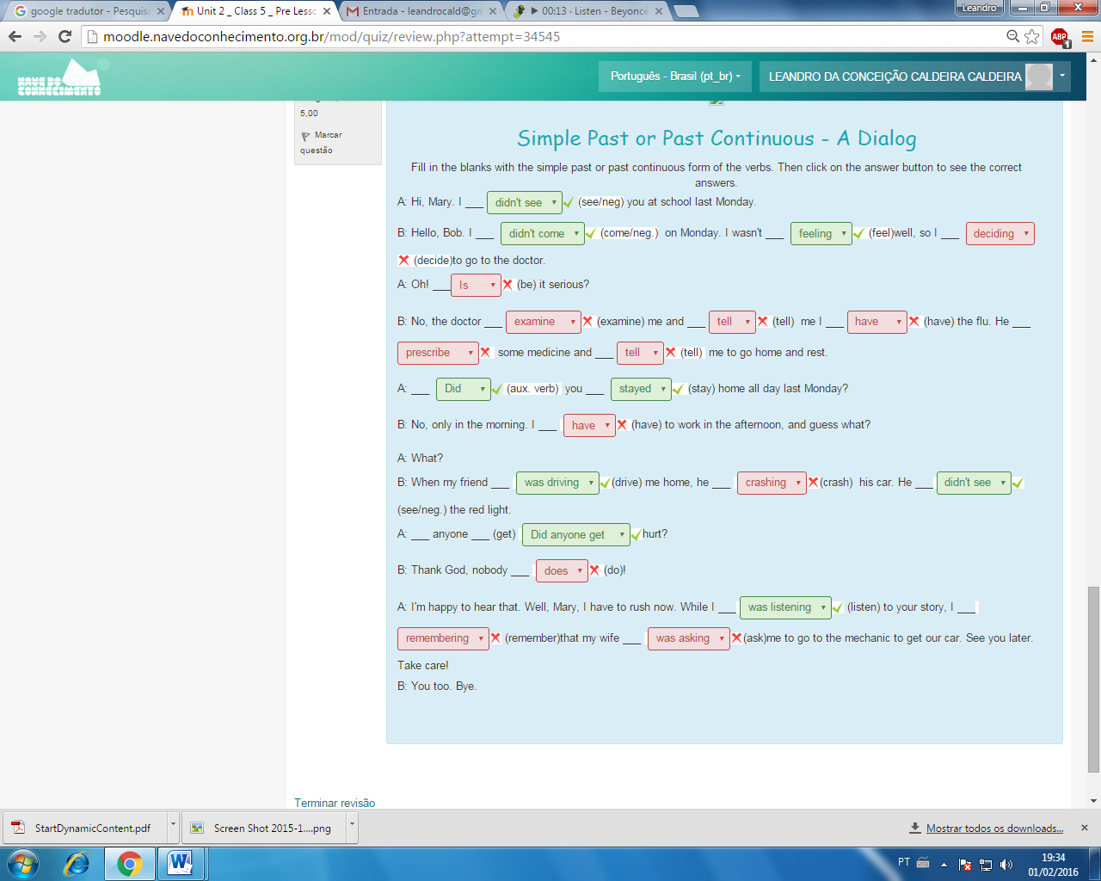

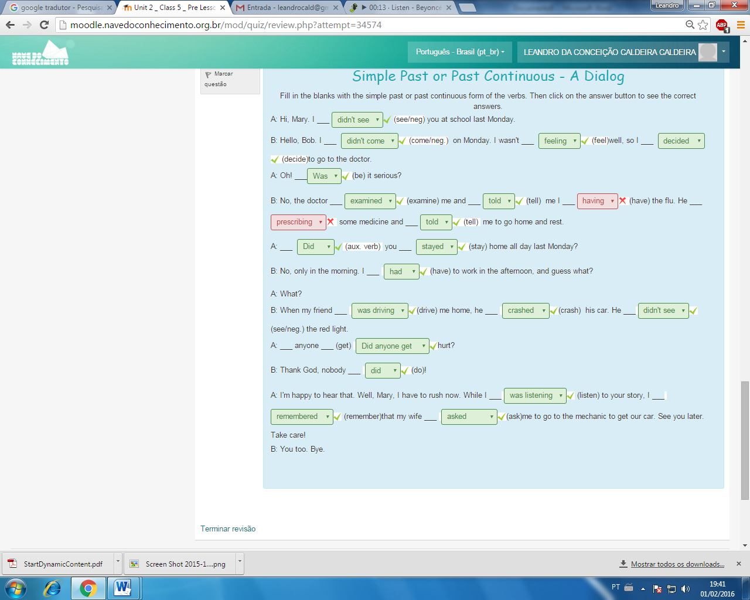

|  |
| --- |
| Good Advice: advice and suggestions |

Giving advice and making suggestions are two different language functions, but in real life they often go together. Let’s see here some very common constructions you can use to give advice.

|  |  |
| --- | --- |
| **SHOULD**      You should go to the doctor, he’ll tell you what to do      You shouldn’t go to bed so late, you need more sleep  **WHY DON’T YOU**      I know it’s difficult to find, but why don’t you look on the Internet?      Why don’t you wait here for a moment, I’m sure she will be back very soon  **HOW ABOUT** + ING (or YOU + bare infinitive)      You look bored. How about going for a walk? We could go to the river.      How about you stay here and I go and look for help? | doubt |

**MUST/HAVE TO** [strong advice]  
     You must go to the doctor immediately, that looks serious.  
     You have to take her to that movie, she’s going to love it.  
  
**IF I WERE YOU** (+ would)  
     If I were you, I’d send her an e-mail saying sorry  
     If I were you, I wouldn’t buy that book  
  
**SUGGEST** (+ that you (should) )  
     I suggest that you eat more vegetables  
     I suggest that you should take a holiday, you look so tired  
  
**IMPERATIVES** (start, stop, try, consider...) + ing  
     Stop drinking so much coffee, it’s not healthy  
     Start going to the gym  
     Try talking to him, you may convince him  
     Consider buying a new bicycle and give the old one to your little brothe

http://www.multimedia-english.com/recursos/pix/etc/attention.png **TIP**: Muitas pessoas não gostam de conselhos "gratuitos". É importante tomar cuidado e para evitar uma impressão errada, você pode tentar algumas destas expressões:

|  |  |
| --- | --- |
| **I think you should restart your computer.**       You could always…*restart your computer*      Have you considered… *restarting your computer?*      Have you thought about… *restarting your computer?*             Perhaps we could…*restart your computer*      In your position, I would… *restart your computer*      You should perhaps… *restart your computer*      It may be a good idea to... *restart your computer*      Maybe you can... *restart your computer* | question |

**I think you shouldn’t tell your parents**  
  
     Do you think it's a good idea to…*restart your computer?*  
     Are you sure it’s a good idea to... *restart your computer?*  
     I don’t know if it’s a good idea to...*restart your computer*  
     I don’t know about you, but I would never... *restart your computer*  
     Maybe you should think twice if you’re going to... *restart your computer*  
     I’m not so sure about... *restarting your computer*  
And, of course, we can also use the positive phrases in the negative:  
     You could always not... *restart your computer*  
     Have you considered not... *restarting your computer?*  
     It may be a good idea not to...*restart your computer*  
     etc

Por que você não

     Eu sei que é difícil de encontrar, mas por que você não olhar sobre a Internet?

     Por que você não esperar aqui por um momento, eu tenho certeza que ela vai estar de volta muito em breve

COMO SOBRE + ING (ou você + infinitivo nu)

     Você parece entediado. Que tal ir para um passeio? Nós poderíamos ir para o rio.

     Que tal você ficar aqui e eu ir procurar ajuda? dúvida

DEVE / TEM QUE [conselho forte]

     Você deve ir ao médico imediatamente, que parece sério.

     Você tem que levá-la para esse filme, ela vai adorar.

Se eu fosse você (+ faria)

     Se eu fosse você, eu iria enviar-lhe um e-mail dizendo arrependido

     Se eu fosse você, eu não iria comprar esse livro

SUGERIR (+ que você (deve))

     Eu sugiro que você comer mais vegetais

     Eu sugiro que você deve tomar um feriado, você está tão cansado

IMPERATIVOS (iniciar, parar, tentar, considere ...) + ing

     Pare de beber muito café, não é saudável

     Comece indo para a academia

     Tente falar com ele, você pode convencê-lo

     Considere a compra de uma bicicleta nova e dar o antigo para seu pequeno brothe